Impacts of land use changes (2001-2021) on wildfire risk in San Diego County, California

Max SCHNEEBERGER1

1Z_GIS, University of Salzburg, Austria ∙ max.schneeberger@stud.plus.ac.at

Abstract

In recent decades, the frequency and severity of wildfires have increased dramatically, driven by climate change and unsustainable land use practices. This thesis analyzes the spatial expansion of the wildland-urban interface (WUI) in San Diego County, California, between 2001 and 2021 and evaluates its intersection with wildfire risk zones. A hybrid methodology was implemented, combining a WUI extraction workflow based on land use raster data with a wildfire risk mapping framework originally developed by the Portuguese Municipal Commission for the Defense of the Forest Against Fire. To ensure methodological compatibility, a customized matching table was created to align Portuguese land use categories with those used by the U.S. Geological Survey. The study found that WUI areas in San Diego County expanded by approximately 100 km² over the 20-year period, and that roughly 90 km² of WUIs in 2021 are located in zones classified as high or very high wildfire risk. While the WUI delineation approach produced some false positives, these are considered acceptable in light of the need to avoid underestimating exposure. The resulting maps and figures serve as a valuable decision-support tool for land use planning and wildfire mitigation strategies. The findings highlight the urgency of monitoring WUI growth and targeting high-risk areas with adaptive management policies.

# Introduction

Severe wildfires have been increasing dramatically in recent years, causing not only significant financial damage but also far-reaching consequences for human health and the environment. This trend is primarily driven by changing climate patterns such as variations in temperature, precipitation and prolonged drought periods. Additionally, detrimental land management also is a contributing factor to the decreasing resilience of ecosystems to uncontrolled fires. Therefore, in addition to combating climate change, it is essential that sensible land use policies are developed. While many countries already have established measures to ensure sustainable land development, additional actions are needed. These include, among others, more granular wildfire hazard evaluations to more effectively evaluate future wildfire risk. (OECD, 2023)

Areas that are particularly prone to wildfire damage are called the wildland-urban interface (WUI). In these sites, the constructed environment and natural vegetation meet, exposing residents to highly flammable areas. In the western part of the United States, the expansion of these zones led to a 246% increase in destruction of physical infrastructure since 2000. (Higuera et al., 2023) To minimize human exposure in such high-risk areas, wildfire hazard assessments need to be incorporated into land management (Kocher & Butsic, 2017).

This study aims to analyze the changes in land use in San Diego County, California from 2001 – 2021. The focus lies on where wildland-urban interfaces have expanded and where the WUIs of 2021 intersect with high-risk wildfire zones. It is hypothesized that there has been a significant expansion of the wildland urban interface from 2001 to 2021 and that a profound amount of the WUIs of 2021 overlap with high-risk wildfire zones. The derived maps and measurable overlapping areas gained from this work will help decision-makers focus their efforts on the mitigation of wildland urban sprawl, to regions particularly susceptible to uncontrolled fires.

# Materials and Methods

## Case Study Area

San Diego County is situated in Southern California and characterized by a heterogenous geography encompassing coastal regions, mountainous terrains, and arid landscapes. It extends across approximately 10900 square kilometers and accommodates a population exceeding 3 million. The county consists of 18 incorporated cities and numerous non-municipal settlements. The region is defined by hot, dry summers and mild, wet winters forming a Mediterranean climate. San Diego County is also abundant in biodiversity, with ecosystems spanning from chaparral and oak woodlands to coastal wetlands and desert habitats. With its rich history of wildfires, San Diego is an ideal case study location for this project. (KERN, 1977; NASA, 2025; sandiego.org, n.d.) Figure 1 shows a cartographic representation of the study area.

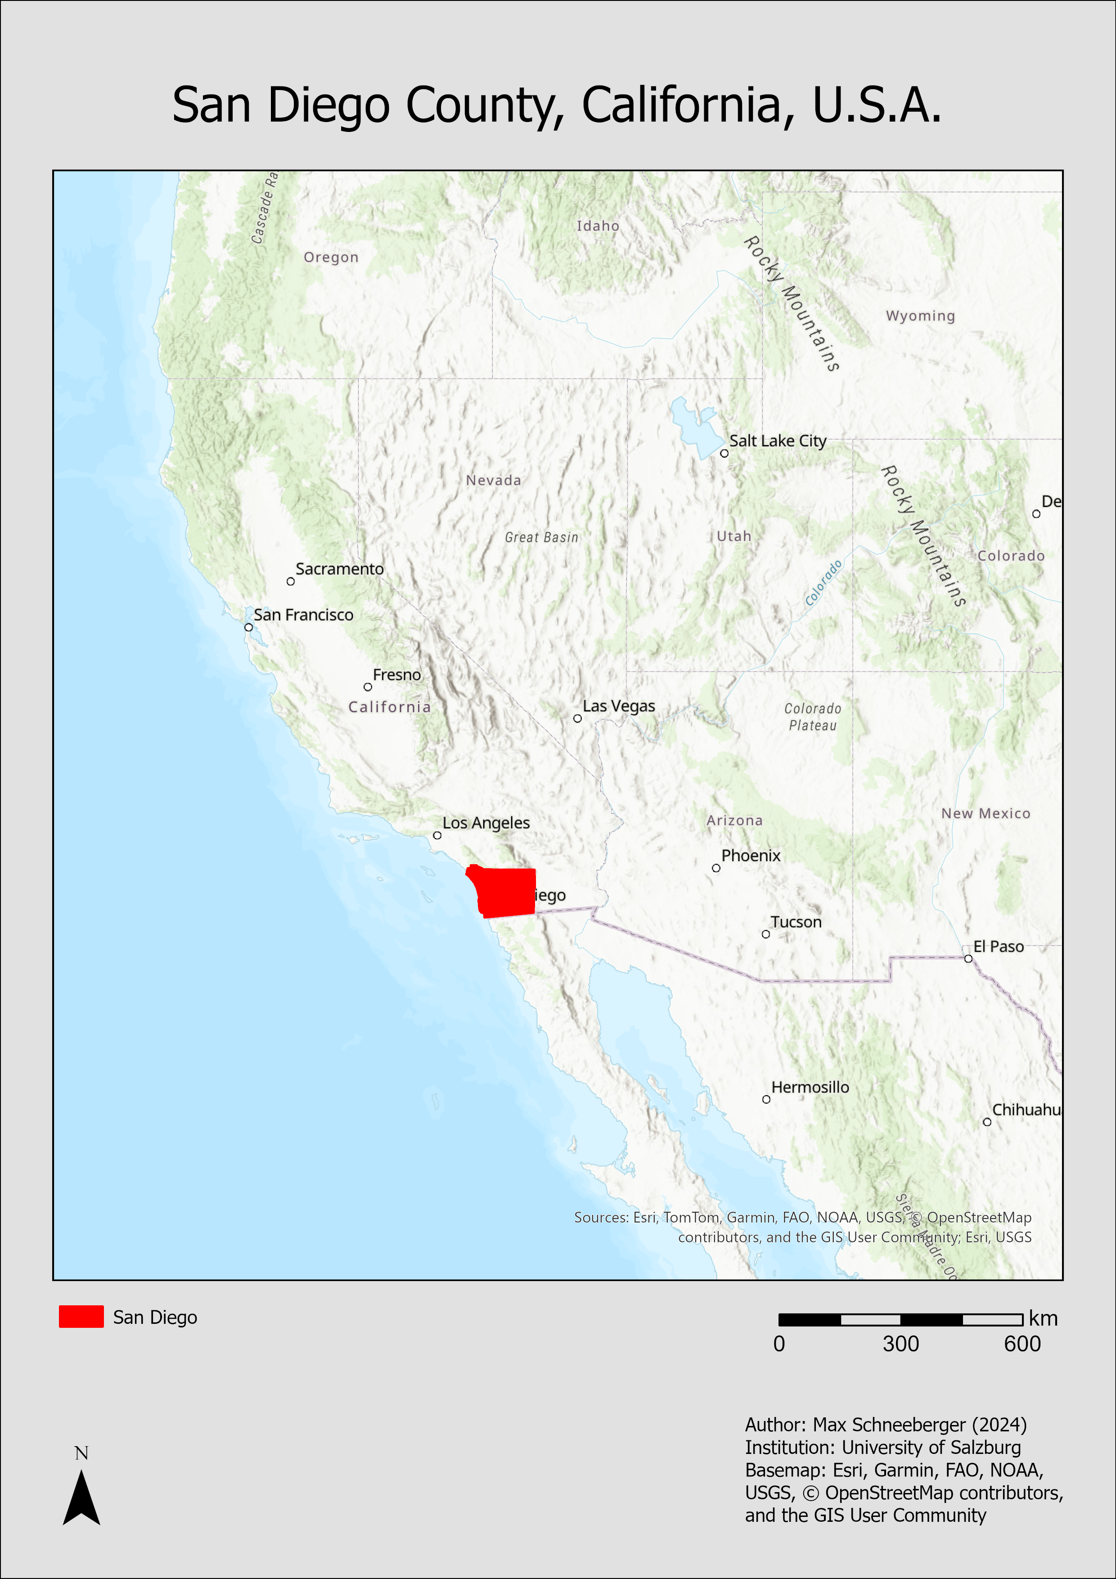

Figure 1: Map of California highlighting San Diego County

## Data, Software, Hardware

The study relies on several datasets to conduct the WUI extraction analysis and the wildfire risk mapping. Table 1 shows an overview of the used data.

Table 1: Datasets used, including description and source

ArcGIS Pro 3.4 is used as the main software package for the analysis workflows. Additionally, Python is utilized for data cleaning and automatization. The entire workflow is conducted on a high-performance Lenovo workstation.

## Methods

In the western part of the United States, areas where human settlements progress into undeveloped land (called wildland-urban interface (WUI)) are extending. This leads to an amplified wildfire risk to the population living in those zones. While there have been initiatives to map the spread of WUIs, the census-based approaches used, only provide insights at regional and national scales. For accurate fire risk mitigation measures, more granular methods and maps are needed. (Caggiano et al., 2016) Alternative approaches to more accurately map WUIs include acquiring building sites with GPS units (Calkin et al., 2011), employing proxies for building locations, including addresses or parcel centroids (Platt, 2010), OBIA approaches (Caggiano et al., 2016) or manual techniques incorporating digitizing building outlines from local government data or arial imagery (Lowell et al., 2009).

Due to the medium extent of the area of interest, this study introduced a mixed approach in mapping wildland-urban interfaces. Two land cover raster files (from 2001 and 2021) clipped to San Diego County published by the U.S. Geological Survey (USGS) served as the main entry point for the analysis. Utilizing ArcGIS Pro, the land cover rasters have been reclassified into two classes, human settlements = 1 and wildland = 0. The remains of the previous classes were set to NODATA cells. To extract WUIs from the reclassified raster images, a zonal statistics approach was employed. First, the entire study area was overlayed with a hexagon grid where each hexagon has an area of two km2. After that, all the cells inside each hexagon which are categorized as urban have been summed up. Based on this calculated value, a threshold range of approximately 150 urban cells to 1800 urban cells was introduced – hexagons that have an urban cell value inside this range have been categorized as WUIs. To validate the results, manual visual assessment was conducted for the whole area of interest. A graphical depiction of the WUI extraction workflow can be seen in Figure 2.

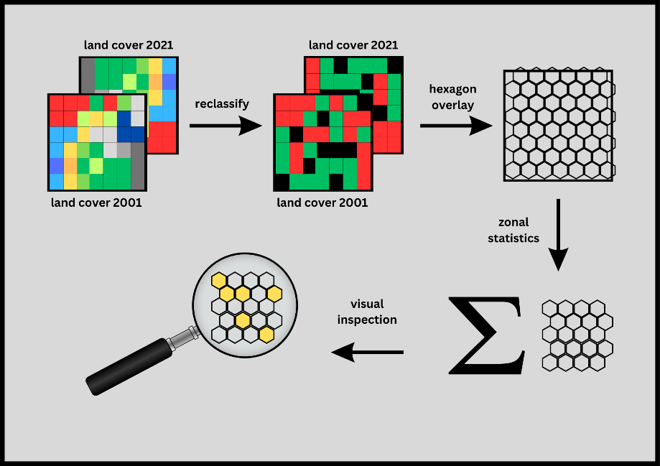

Figure 2: WUI extraction workflow

The second part of the methodology consisted of a wildfire risk mapping workflow introduced by the Portuguese Municipal Commission for the Defense of the Forest Against Fire (CMDFCI, 2018). A wildfire risk map was constructed from a hazard map and a potential damage map. Hazard is determined as the product of probability and susceptibility and potential damage is calculated as the product of vulnerability and economic value – see Figure 3.

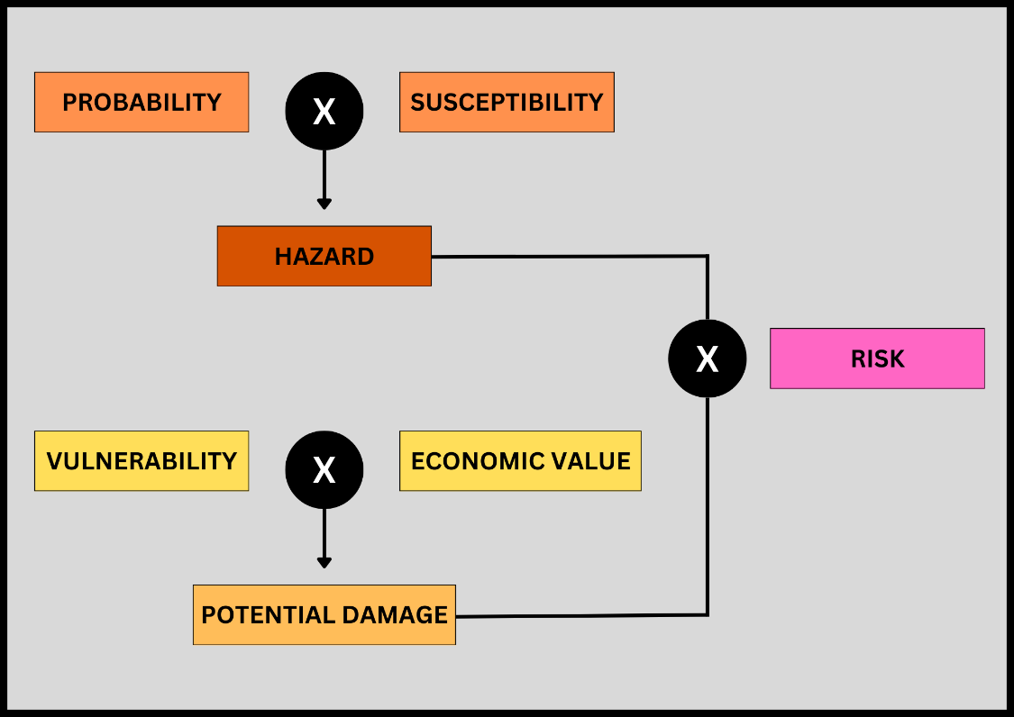

Figure 3: wildfire risk mapping workflow

The process of creating a wildfire risk map started with the construction of two essential maps: the hazard map and the potential damage map. The hazard map was derived by considering both the probability and susceptibility of wildfire occurrence in the study area. Probability refers to the likelihood of wildfire occurring, while susceptibility represents the area's vulnerability to wildfires based on environmental factors. These two components were then combined to generate the hazard map, which highlights areas of varying wildfire risk based on these factors.

Next, the potential damage map was created by assessing the vulnerability of the land and the economic value associated with each land use or land cover type. Vulnerability is a measure of how susceptible an area is to damage from wildfires, and it is quantified on a scale from low to high. Economic value, on the other hand, represents the economic worth of the land in terms of its productive capacity, often measured per hectare. The potential damage map was then generated by multiplying the vulnerability values by the corresponding economic values for each land use or land cover type.

Once hazard and potential damage maps have been created, they were combined to produce the final wildfire risk map. This was done by multiplying the hazard map with the potential damage map (Map-Algebra), resulting in a map that reflects both the likelihood of a wildfire occurring and the potential damage it could cause. The resulting risk map was then classified into five different risk categories, ranging from very low to very high, to facilitate interpretation and decision-making. To answer the research question, it was then assessed if areas assigned with a high- or very high-risk category overlap with 2021 WUIs. For a more detailed description on the wildfire risk mapping workflow, please refer to (CMDFCI, 2018).

# Results

Figure 4 shows a map of the wildfire risk in San Diego County for the year 2024. Areas with the highest wildfire risk (high and very high) include: the region of Jamul Mountains as well as Sycamore and Cedar Canyon in the south, the region of Sunshine Mountain in the center, San Ysidro Mountain in the northwest, the region around Pine Mountain northwest of the center and Aliso Canyon in the northwestern part of San Diego County.

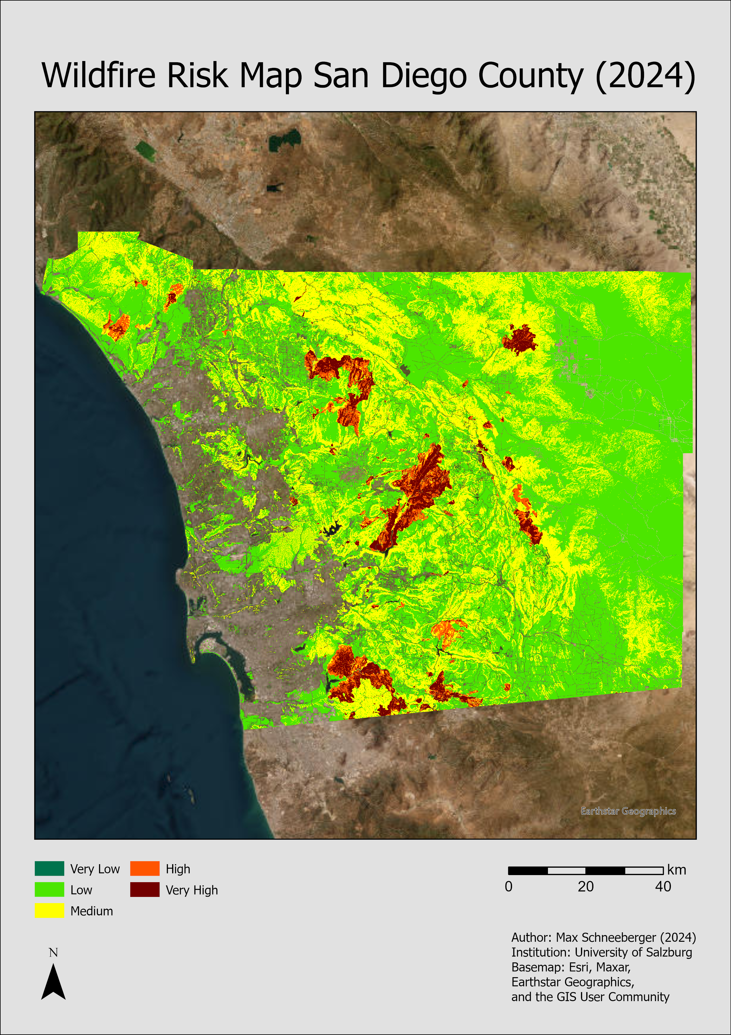

Figure 4: Wildfire Risk Map San Diego County (2024)

Figure 5 shows a map of the wildland urban interface expansion from 2001 to 2021. The salmon-colored areas represent the WUIs for 2001 and the green areas represent the additional WUIs that expanded until the year 2021. The expansion corresponds to an area of approximately 100km2.

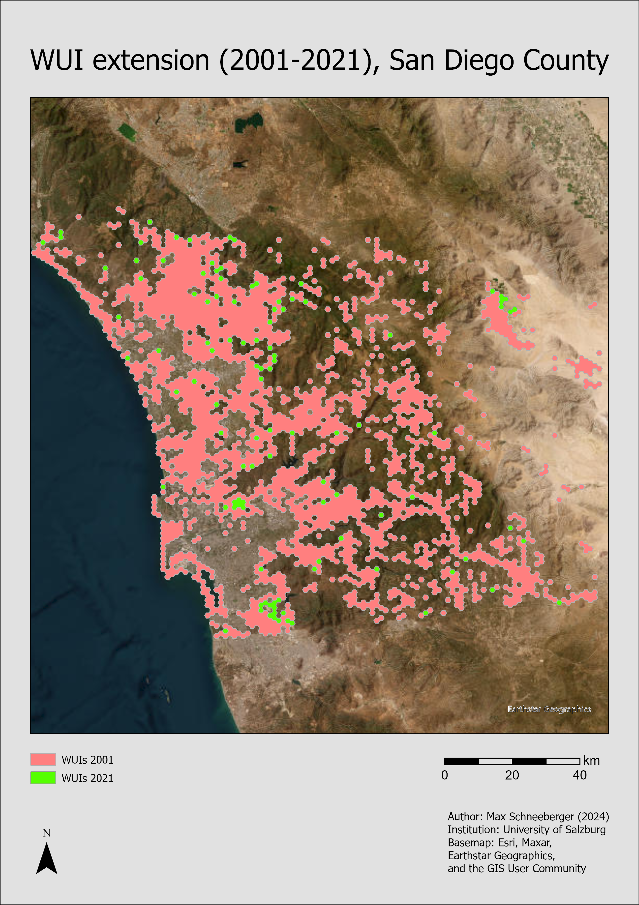

Figure 5: WUI extension (2001-2021)

Figure 6 shows a map of the high-risk wildland urban interface areas of 2021 (the intersection of the 2021 WUIs with wildfire zones of high or very high risk). Approximately 90km2 fall in this category.

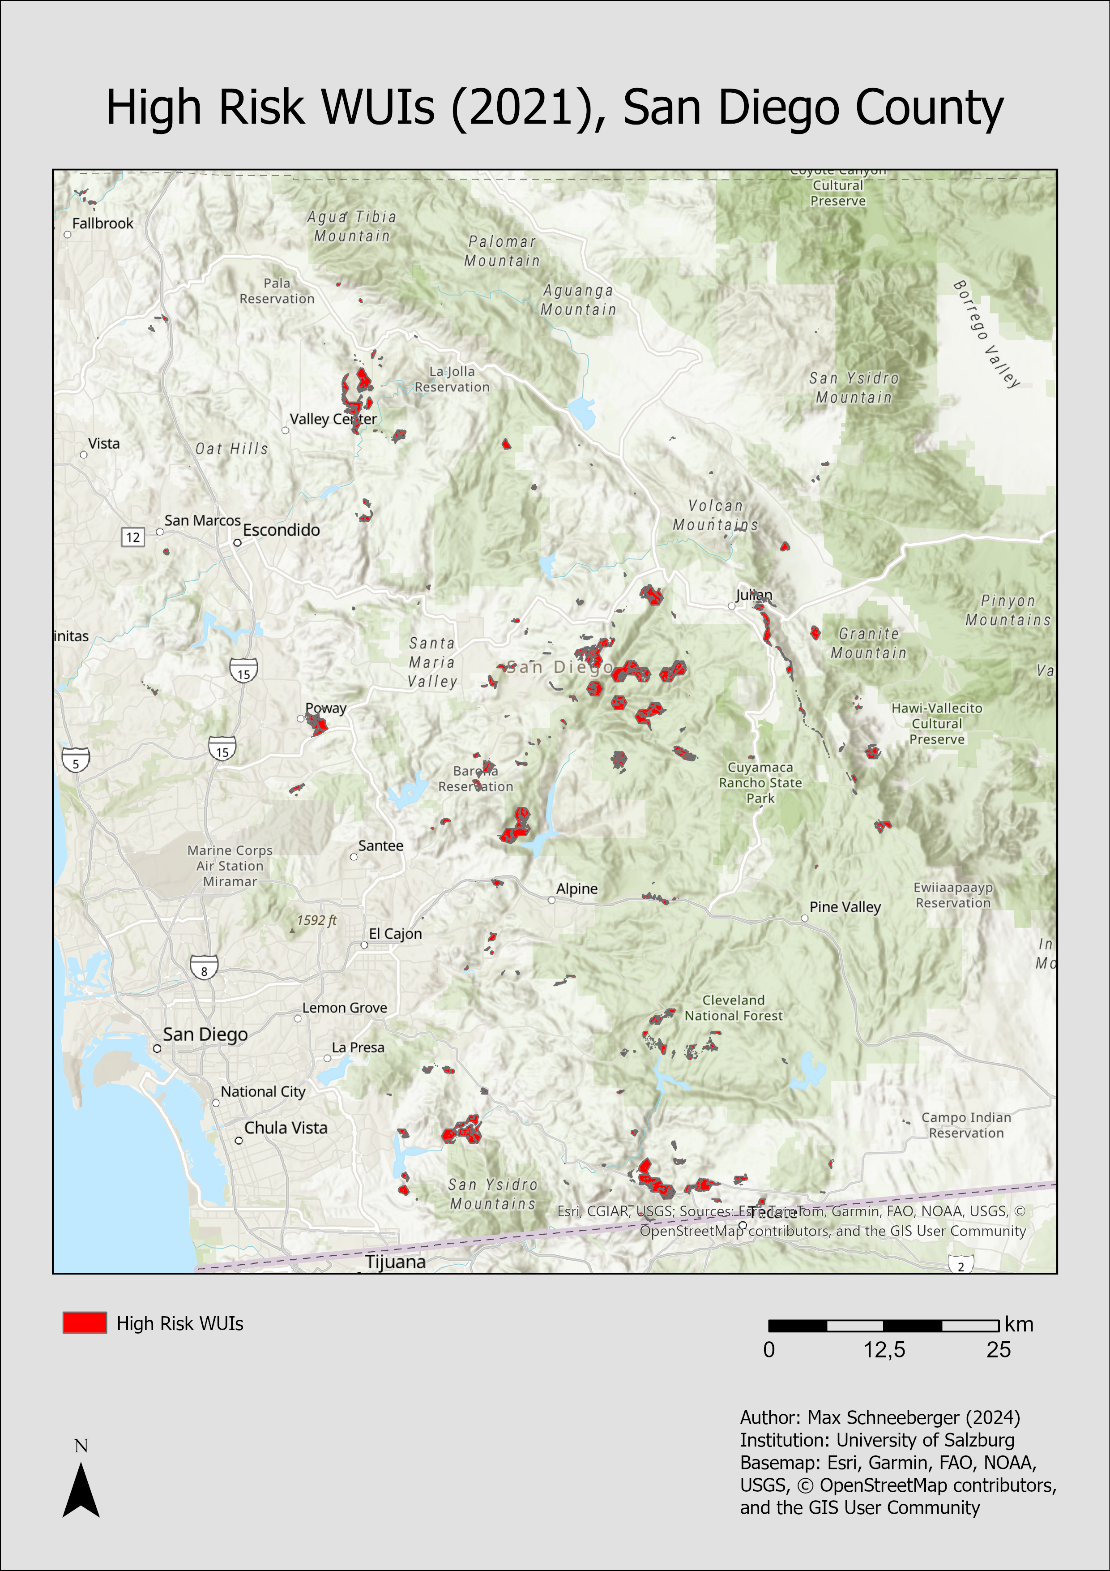

Figure 6: High Risk WUIs (2021)

# Discussion

This study demonstrated that the wildfire risk mapping methodology developed by the Portuguese Municipal Commission for the Defense of the Forest Against Fire   
(CMDFCI, 2018) can be successfully adapted and applied to the context of San Diego County. The general structure of integrating hazard and potential damage into a composite risk index proved both conceptually sound and technically feasible when using publicly available datasets. Nonetheless, one of the key challenges encountered was the incompatibility between the land use classification systems used in Portugal and those available for California. Since land use categories are central to the wildfire risk mapping workflow, a matching table was developed to harmonize the Portuguese categories with the USGS land use classes. This table (see under https://git.sbg.ac.at/s1102917/flare/-/blob/main/Data/landuse_matching_table.xlsx) enabled a coherent translation of the methodology and maintained the integrity of the original approach.

The wildland-urban interface (WUI) extraction workflow, based on a zonal statistics approach over a hexagonal grid, successfully delineated the majority of true WUIs. The results were validated through manual inspection, and the method demonstrated high spatial precision. While some false positives were detected (areas erroneously classified as WUI) which has been an ongoing challenge in similar work (Caggiano et al., 2016; Calkin et al., 2011; Lowell et al., 2009; Platt, 2010), these are considered acceptable in this context. From a wildfire risk management perspective, false positives are less problematic than false negatives, as the primary goal is to ensure no high-risk areas are missed. Given that this analysis is meant as an entry point for further investigation, the inclusion of some low-risk zones within the WUI output does not undermine its utility. In fact, it strengthens the risk-averse nature of the workflow by ensuring comprehensive coverage of potentially vulnerable regions.

A notable outcome of this study is the identification of approximately 90 km² of high-risk WUI areas in 2021 – locations where human development intersects with zones of high or very high wildfire risk. This figure underscores the magnitude of the challenge in San Diego County. Nearly 1% of the county’s total area is subject to both intense wildfire threat and human presence, highlighting the urgency for targeted policy interventions in land use planning already noted by Kocher and Butsic (2017). These high-risk WUIs serve as critical priority zones where land management, fire mitigation efforts, and potential development restrictions should be concentrated.

The observed expansion of WUIs from 2001 to 2021, totaling roughly 100 km², further reflects the growing invasion of human settlements into fire-prone wildlands and supports the findings of Higuera et al. (2023). This expansion trend, if unchecked, will likely exacerbate the impacts of wildfires on both infrastructure and human life. The temporal comparison conducted in this study provides a useful benchmark for future assessments and reinforces the need for integrating WUI monitoring into regional planning processes.

# Conclusion and Outlook

This study set out to assess the spatial dynamics of wildfire exposure in San Diego County by analyzing wildland-urban interface (WUI) expansion and its intersection with wildfire risk zones between 2001 and 2021. By adapting a Portuguese wildfire risk mapping methodology (CMDFCI, 2018) to a Californian context, the research demonstrated the viability of international methodological transfer – provided that appropriate data harmonization steps, such as land use classification matching, are carefully implemented.

The findings confirmed a significant expansion of WUIs over the 20-year period, totaling approximately 100 km², and identified around 90 km² of current WUI areas that fall within high or very high wildfire risk zones. These areas should be regarded as critical zones for targeted mitigation strategies, urban planning revisions, and public awareness efforts. The study also showed that the employed mixed-method WUI extraction workflow, leveraging raster reclassification and zonal statistics within a hexagonal grid, offers a practical and relatively accurate tool for mapping these interfaces in medium-scale geographies.

While the methodology successfully highlights priority zones for risk management, the results must be interpreted with an understanding of their inherent limitations. Some false positives were noted in the WUI outputs, but this is a tolerable trade-off given the overarching goal of ensuring that high-risk areas are not overlooked. Furthermore, the wildfire risk output, though grounded in solid conceptual foundations, remains a model-based abstraction. Local factors such as vegetation moisture content, prevailing winds, and emergency access routes, which are difficult to quantify at this scale, were not included but can significantly influence actual fire behavior and risk.

Looking ahead, several avenues for future work emerge. First, incorporating dynamic environmental variables such as real-time vegetation indices or meteorological data could refine hazard assessments. Second, more granular building footprint data and locally verified land use maps could enhance the spatial resolution and accuracy of WUI delineation. Third, coupling this spatial analysis with socioeconomic vulnerability assessments would provide a more holistic view of wildfire exposure, allowing decision-makers to prioritize interventions based not only on geographic risk but also on social resilience.

Lastly, repeating this workflow for other counties in California would provide a comparative basis for understanding wildfire risk evolution in different contexts. As wildfires continue to intensify under climate change, tools and methodologies like the ones developed in this thesis will become increasingly vital to adaptive, data-driven land use planning and disaster risk reduction.

# Affidavit

I hereby declare on oath that I have written this work independently and have not used any sources or aids other than those stated. All passages that have been taken verbatim or in terms of content from the stated sources are marked as such. Throughout the development of this work, the AI language model ChatGPT-4o mini was utilized for grammatical corrections. The model assisted in refining sentence structures, improving clarity, and ensuring grammatical accuracy. All conceptual content, ideas, analysis, and conclusions presented in this work remain the sole work and responsibility of the author.

# Acknowledgements

I would like to thank Prof. Klug, Prof. Mittlböck, Prof. Wendt, and Prof. Gella for the ongoing supervision and consultancy throughout this project.

# References

Caggiano, M. D., Tinkham, W. T., Hoffman, C., Cheng, A. S., & Hawbaker, T. J. (2016). High resolution mapping of development in the wildland-urban interface using object based image extraction. *Heliyon*, *2*(10), e00174. https://doi.org/10.1016/j.heliyon.2016.e00174

Calkin, D. E., Rieck, J. D., Hyde, K. D., & Kaiden, J. D. (2011). Built structure identification in wildland fire decision support. *International Journal of Wildland Fire*, *20*(1), 78–90. https://doi.org/10.1071/WF09137

CMDFCI. (2018, November). *Proposed Revision of Rural Fire Risk Mapping*. Municipal Commission for the Defense of the Forest Against Fire (Portugal).

Higuera, P. E., Cook, M. C., Balch, J. K., Stavros, E. N., Mahood, A. L., & St. Denis, L. A. (2023). Shifting social-ecological fire regimes explain increasing structure loss from Western wildfires. *PNAS Nexus*, *2*(3), pgad005. https://doi.org/10.1093/pnasnexus/pgad005

KERN, J. P. (1977). Origin and history of upper Pleistocene marine terraces, San Diego, California. *GSA Bulletin*, *88*(11), 1553–1566. https://doi.org/10.1130/0016-7606(1977)88<1553:OAHOUP>2.0.CO;2

Kocher, S. D., & Butsic, V. (2017). Governance of Land Use Planning to Reduce Fire Risk to Homes Mediterranean France and California. *Land*, *6*(2), Article 2. https://doi.org/10.3390/land6020024

Lowell, K., Shamir, R., Siqueira, A., White, J., O’Connor, A., Butcher, G., Garvey, M., & Niven, M. (2009). Assessing the capabilities of geospatial data to map built structures and evaluate their bushfire threat. *International Journal of Wildland Fire*, *18*(8), 1010–1020. https://doi.org/10.1071/WF08077

NASA. (2025, February 10). *NASA-Led Study Pinpoints Areas Sinking, Rising Along California Coast—NASA*. https://www.nasa.gov/missions/nisar/nasa-led-study-pinpoints-areas-sinking-rising-along-california-coast/

OECD. (2023). *Taming Wildfires in the Context of Climate Change* (1st ed). Organization for Economic Cooperation & Development.

Platt, R. V. (2010). The Wildland–Urban Interface: Evaluating the Definition Effect. *Journal of Forestry*, *108*(1), 9–15. https://doi.org/10.1093/jof/108.1.9

sandiego.org. (n.d.). *About San Diego, California*. Retrieved March 19, 2025, from https://www.sandiego.org/articles/about-san-diego-ca.aspx